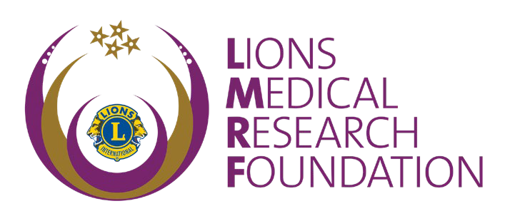
COMMUNITY SERVICE AWARD ORDER FORM
Honour a colleague with a

LIONS MEDICAL RESEARCH FOUNDATION COMMUNITY SERVICE AWARD
The Community Service Award is presented to an organisation or individual whose commitment to community service is exemplary. This award acknowledges that ‘community is what we make it’, and service to our community in support of medical research is recognised, appreciated and valued.

This Award can be used to acknowledge individuals or organisations and can be awarded to Lions and non-Lions. An individual or organisation may be nominated to receive this Award by a Lions Club, Leo Club or District Cabinet. Membership of Lions Clubs International is not a prerequisite.

The amount of $250 is required as a contribution to the Foundation to qualify for the Award.

The nominated recipient will receive an inscribed glass plaque. The Award will be forwarded through the Lions Medical Research Foundation office.

Please complete this application form and return to Lions Medical Research Foundation.

Recipient name:

Donated by (name and Club and District):

Date of presentation:

Delivery address (please supply name, phone number and residential address) _

Please supply a brief paragraph of text you wish to have on the recipient’s award letter signed by the LMRF Chairman (no more than 100 words)

Please email this form to info@lmrf.org.au and payment to be deposited electronically to Account name: Lions Medical Research Foundation
BSB: 014-002
Account: 3619 54643
Reference: Award <your Club name>

Or alternatively you may attach your cheque for $250 to this application and forward to the address below or if you have credits available. Credits are available for 2 years from date of donation.
Thank you for your order.
Lions Medical Research Foundation
GPO Box 1030 P. 07 3832 1688
Brisbane QLD 4001 E: info@lmrf.org.au

